H.T No
Regulations:
A14

Sreenidhi Institute of Science and Technology
(An Autonomous Institution)
Code No: 4B202 Date: 19-Nov-2020 (FN)

B.Tech I-Year II-Semester External Examination, Nov/Dec - 2020 (Supplementary)
Engineering Drawing – II (Common to All)

Time: 2 Hours Max.Marks:70

Note: a) No additional answer sheets will be provided.
b) All sub-parts of a question must be answered at one place only, otherwise it will not be valued.
c) Missing data can be assumed suitably.

ANSWER ANY 5 OUT OF 8 QUESTIONS. EACH QUESTION CARRIES 14 MARKS.

1. |  | Construct a diagonal scale 1/50, showing metres, decimetres and centimetres, to measure up to 5 metres. Mark a length 4.75 m on it. | [14M]
2. |  | construct a vernier scale to read metres, decimetres and centimetres and long enough to measure upto 4m. The RF of the scale in 1/120. Mark on it a distance of 2.28m. | [14M]
3. |  | A pentagonal pyramid, side of base 30mm and height 60mm, stands with its base on H.P and an edge of the base is parallel to V.P. It is cut by a plane perpendicular to V.P, inclined at 40º to H.P and passing through a point on the axis, 32m above the base. Draw the sectional top view and develop the lateral surface of the truncated pyramid. | [14M]
4. |  | 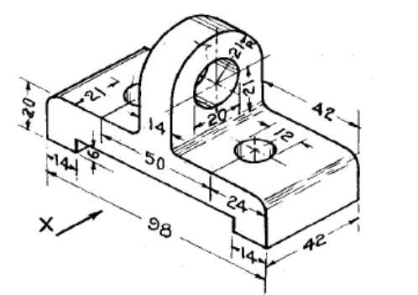  Draw the front view , top view for the diagram shown in figure. | [14M]
5. |  | A cone of base diameter 20mm and height 50 mm is mounted centrally on the top of square prism of side 40 mm and height 60 mm . Draw the isometric projection of the combined solid | [14M]
6. |  | Draw the isometric view of hexagonal prism of base side 30 mm and height 60 mm when the axis is (i) horizontal (ii) vertical | [14M]
7. |  | A rectangular block, 30 mm x 20 mm x 15 mm, is lying on the ground plane on one of its largest faces. A vertical edge is in the picture plane and the longer face containing that edge makes an angle of 30° with the picture plane. The station point is 50 mm in front of the picture plane, 30 mm above the ground plane and lies in a central plane which passes through the centre of the block. Draw the perspective view of the block. | [14M]
8. |  | Explain about different methods of generating lines and simple solids in a computer aided drafting packages. | [14M]

-- 00 -- 00 –

